Civil war in Georgia

UNSC Resolution: | 1287
Date of adoption: | 01/31/00
Operative paragraph: | 2
Demand number: | 1287.0211

David Siroky

Wording of demand

sieze the opportunity of the appointment of a new Special Representative of the Secretary-General to renew their commitment to the peace process

List of addressees of the demand

Government of Georgia, Abkhazia

Short-term compliance

Description of the addressee(s)’ conduct

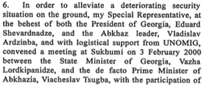

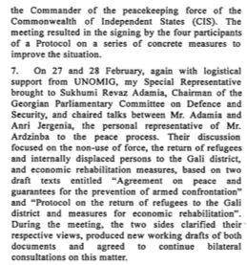

S/2000/345
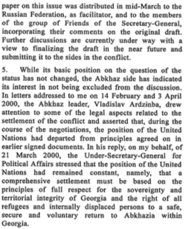

S/2000/345

Assessment

Short-term compliance
No or marginal compliance (1) | Medium low compliance (2) | Medium high compliance (3) | Full or almost full compliance (4)

Considerations underlying the assessment

Medium-term compliance

Description of the addressee(s)’ conduct

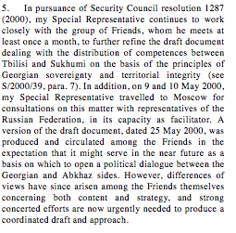

S/2000/697

Assessment

Medium-term compliance
No or marginal compliance (1) | Medium low compliance (2) | Medium high compliance (3) | Full or almost full compliance (4)

Considerations underlying the assessment

Depth of demand

Assessment

Level of depth of demand
Low depth of demand (1) | Medium depth of demand (2) | High depth of demand (3)

Considerations underlying the assessment

Level of confidence about coding decisions

Level of confidence about coding decision
Extremely high | High | Moderate

Comments to IPI (if any)

Civil war in Georgia

UNSC Resolution: | 1287
Date of adoption: | 01/31/00
Operative paragraph: | 4
Demand number: | 1287.0411

David Siroky

Wording of demand

deepen commitment to UN-led peace process, continue to expand dialogue, and display without delay the necessary will to achieve substantial results on the key issues of the negotiations, in particular on the distribution of constitutional competencies between Tbilisi and Sukhumi as part of a comprehensive settlement, with full respect for the sovereignty and territorial integrity of Georgia within its internationally recognized borders

List of addressees of the demand

Government of Georgia, Abkhazia

Short-term compliance

Description of the addressee(s)’ conduct

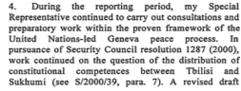

S/2000/345

Assessment

Short-term compliance
No or marginal compliance (1) | Medium low compliance (2) | Medium high compliance (3) | Full or almost full compliance (4)

Considerations underlying the assessment

Medium-term compliance

Description of the addressee(s)’ conduct

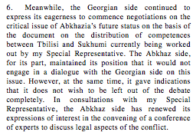
S/2000/697

Assessment

Medium-term compliance
No or marginal compliance (1) | Medium low compliance (2) | Medium high compliance (3) | Full or almost full compliance (4)

Considerations underlying the assessment

Depth of demand

Assessment

Level of depth of demand
Low depth of demand (1) | Medium depth of demand (2) | High depth of demand (3)

Considerations underlying the assessment

Level of confidence about coding decisions

Level of confidence about coding decision
Extremely high | High | Moderate

Comments to IPI (if any)

Civil war in Georgia

UNSC Resolution: | 1287
Date of adoption: | 01/31/00
Operative paragraph: | 6
Demand number: | 1287.0611

David Siroky

Wording of demand

continue to enhance efforts to implement fully the confidence-building measures agreed to at the Athens and Istanbul meetings of 16-18 October 1998 and 7-9 June 1999, respectively

List of addressees of the demand

Government of Georgia, Abkhazia

Short-term compliance

Description of the addressee(s)’ conduct

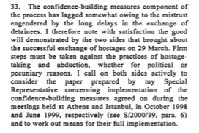

S/2000/345

Assessment

Short-term compliance
No or marginal compliance (1) | Medium low compliance (2) | Medium high compliance (3) | Full or almost full compliance (4)

Considerations underlying the assessment

Medium-term compliance

Description of the addressee(s)’ conduct

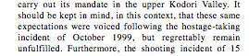

S/2000/697

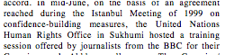
S/2000/697

Assessment

Medium-term compliance
No or marginal compliance (1) | Medium low compliance (2) | Medium high compliance (3) | Full or almost full compliance (4)

Considerations underlying the assessment

Depth of demand

Assessment

Level of depth of demand
Low depth of demand (1) | Medium depth of demand (2) | High depth of demand (3)

Considerations underlying the assessment

Level of confidence about coding decisions

Level of confidence about coding decision
Extremely high | High | Moderate

Comments to IPI (if any)

Civil war in Georgia

UNSC Resolution: | 1287
Date of adoption: | 01/31/00
Operative paragraph: | 7
Demand number: | 1287.0711

David Siroky

Wording of demand

strictly respect human rights

List of addressees of the demand

Government of Georgia, Abkhazia

Short-term compliance

Description of the addressee(s)’ conduct

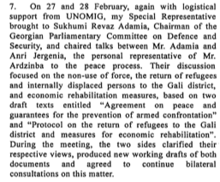

S/2000/345

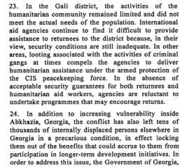

S/2000/345

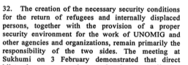
S/2000/345

Assessment

Short-term compliance
No or marginal compliance (1) | Medium low compliance (2) | Medium high compliance (3) | Full or almost full compliance (4)

Considerations underlying the assessment

Medium-term compliance

Description of the addressee(s)’ conduct

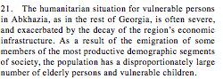

S/2000/697

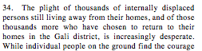
S/2000/697

Assessment

Medium-term compliance
No or marginal compliance (1) | Medium low compliance (2) | Medium high compliance (3) | Full or almost full compliance (4)

Considerations underlying the assessment

Depth of demand

Assessment

Level of depth of demand
Low depth of demand (1) | Medium depth of demand (2) | High depth of demand (3)

Considerations underlying the assessment

Level of confidence about coding decisions

Level of confidence about coding decision
Extremely high | High | Moderate

Comments to IPI (if any)

Civil war in Georgia

UNSC Resolution: | 1287
Date of adoption: | 01/31/00
Operative paragraph: | 8
Demand number: | 1287.0811

David Siroky

Wording of demand

address the issue of demographic changes resulting from the conflict and the imprescriptible right of all refugees and displaced persons affected by the conflict to return to their homes in secure conditions, in accordance with international law and as set out by the Quadripartite Agreement (S/1994/397, annex II) by agreeing and implementing effective measures to guarantee the security of those who exercise their unconditional right to return, including those who have already returned

List of addressees of the demand

Government of Georgia, Abkhazia

Short-term compliance

Description of the addressee(s)’ conduct

S/2000/345

S/2000/345

Assessment

Short-term compliance
No or marginal compliance (1) | Medium low compliance (2) | Medium high compliance (3) | Full or almost full compliance (4)

Considerations underlying the assessment

Medium-term compliance

Description of the addressee(s)’ conduct

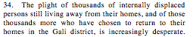

S/2000/697

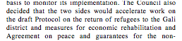

S/2000/697

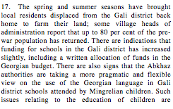
S/2000/697

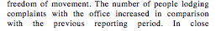

S/2000/697

Assessment

Medium-term compliance
No or marginal compliance (1) | Medium low compliance (2) | Medium high compliance (3) | Full or almost full compliance (4)

Considerations underlying the assessment

Depth of demand

Assessment

Level of depth of demand
Low depth of demand (1) | Medium depth of demand (2) | High depth of demand (3)

Considerations underlying the assessment

Level of confidence about coding decisions

Level of confidence about coding decision
Extremely high | High | Moderate

Comments to IPI (if any)

Civil war in Georgia

UNSC Resolution: | 1287
Date of adoption: | 01/31/00
Operative paragraph: | 9
Demand number: | 1287.0911

David Siroky

Wording of demand

observe strictly the Moscow Agreement (S/1994/583 annex I)

List of addressees of the demand

Government of Georgia, Abkhazia

Short-term compliance

Description of the addressee(s)’ conduct

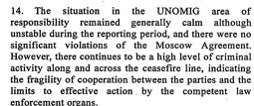

S/2000/345

Assessment

Short-term compliance
No or marginal compliance (1) | Medium low compliance (2) | Medium high compliance (3) | Full or almost full compliance (4)

Considerations underlying the assessment

Medium-term compliance

Description of the addressee(s)’ conduct

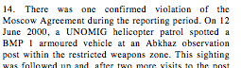

S/2000/697

Assessment

Medium-term compliance
No or marginal compliance (1) | Medium low compliance (2) | Medium high compliance (3) | Full or almost full compliance (4)

Considerations underlying the assessment

Depth of demand

Assessment

Level of depth of demand
Low depth of demand (1) | Medium depth of demand (2) | High depth of demand (3)

Considerations underlying the assessment

Level of confidence about coding decisions

Level of confidence about coding decision
Extremely high | High | Moderate

Comments to IPI (if any)

